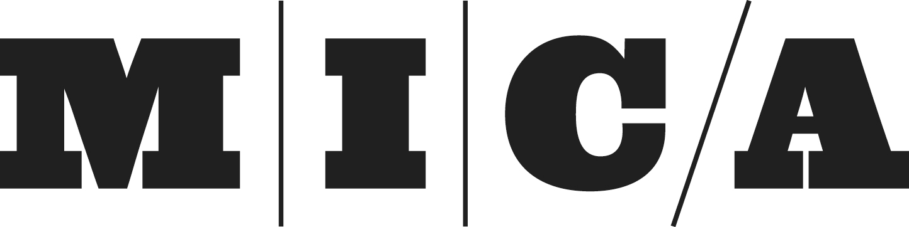

Institutional Review Board Research Closure Form
Instructions:
Please fill out and return this form to the Office of Research within 30 days after your study has concluded or canceled. Please email irb@mica.edu or call the Office of Research at (410) 225-2266 with questions.
Email a signed PDF to: | Mail a signed copy to:
irb@mica.edu | Office of Research, MICA (IRB), 1300 W. Mt. Royal Avenue, Baltimore, MD 21217
______________________________________________________________________________________________

Principal Investigator (PI) Name: | Protocol Number:  (noted on IRB Approval Letter)

Project title:

Enrollment
Total number of participants enrolled:
Total number of participants who completed study:
Participants are (provide number below)
Graduate | Undergraduate | Community Members | Other (please describe)

Unforeseen Events
Total number of unanticipated problems requiring notification of the IRB board:
Complaints: Did the subjects have any complaints about the study? YES or NO
If yes, please describe below:

Certification: I certify that the approved research protocol is complete and should be closed. I understand that the closure of this research protocol means that no further research or follow up with participants may be conducted. If required in the original IRB, all data has been de-identified and that all links to identifiable data has been destroyed. I agree to retain all research materials for at least 3 years after closure of the research project and acknowledge that these documents may be subject to review by the IRB, if deemed necessary. Location of signed Informed Consent Documents (if applicable) which must be kept for three years beyond the conclusion of the research are located (please disclose the location): ____________________________________________________
PI Name: | Faculty Supervisor name (if PI is a student) :
PI signature: | Faculty Supervisor signature (if PI is a student):
Date: | Date:

